**y = m * x + c**

example:

package = m * cgpa + b

here,

m = weightage, tells us the impact of output(y) while changing ‘m’.

c = noise.

In Simple Linear Regression, we don’t use the Modulus, as we need to minimize the Loss function(Error function) and the differentiation of any Modulus function is undefined.

For any outliers, we want to penalize.

1. Calculating the (m,b) using **OLS(Ordinary Least Squares):**

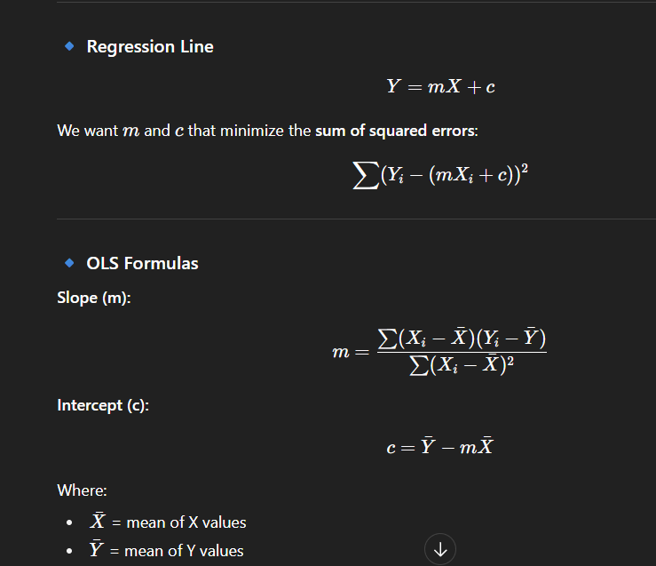

The error function is dependent on (m,b).

The error function is always a convex function.

A convex function has Local minima = Global minima. We need to differentiate the error function w.r.t to both the variables(m,b).

And eventually will get the ‘m’ and ‘c’.